


Amber Beverage Group Holding S.À R.L.
(Registration number B218246)

UNaudited Condensed consolidated financial statements
for three months of year 2025

prepared in accordance with
International Financial Reporting Standards as adopted by the EU

INFORMATION ON THE GROUP 3
Used abbreviations 4
MANAGEMENT REPORT 5
STATEMENT OF THE MANAGEMENTS’ RESPONSIBILITY 11
CONSOLIDATED STATEMENT OF COMPREHENSIVE INCOME 12
CONSOLIDATED STATEMENT OF FINANCIAL POSITION 13
CONSOLIDATED STATEMENT OF CHANGES IN EQUITY 15
CONSOLIDATED CASH FLOW STATEMENT 16
NOTES 17

INFORMATION ON THE GROUP

Name of the Parent Company Amber Beverage Group Holding S.à r.l.

Registration Number No. B218246

Address 44, Rue de la Vallée, Luxembourg, L-2661

Main business activities of the Parent Company Holding and management activities

Major shareholder SPI Group Holding Limited (94%, incorporated in Cyprus)

Names and positions of the Supervisory Board Members
Sir Geoffrey John Mulgan,
Chairman, Member of the Supervisory Board

Mr. Simon Charles Rowe,
Member of the Supervisory Board

Mr. Douglas Brougham Cunningham,
Member of the Supervisory Board
Ms. Sabina Fatkullina
Member of the Supervisory Board

Mr. Arturs Evarts,
Secretary, Member of the Supervisory Board

Names and positions of the Board of Managers Mr. Arturs Evarts,
Chairman of the Board

Used abbreviations

ABG Amber Beverage Group, i.e., Amber Beverage Group Holding S.à r.l. and its subsidiaries
ROA Return on assets calculated as LTM Net Profit (before tax) period divided by Total Assets
ROE Return on Equity calculated as LTM Net Profit (before tax) divided by Total Equity (average)
Debt Borrowings, including external loans, overdrafts, loans from related parties and leases
Net Debt Debt reduced by cash and cash equivalents and short-term deposits
EBITDA Earnings before interest, tax, depreciation, amortisation and impairment of non-financial assets, fair value adjustment on biological assets
Normalized EBITDA EBITDA adjusted by exceptional items
LTM EBITDA EBITDA for the last 12 months period
LTM Net revenue Net revenue for the last 12 months period
9Lcs Equivalent of 9 litre case of goods
LTM Net profit Net profit for last 12 months
LTM Net Profit (before tax) Net profit (before tax) for last 12 months
Equity ratio Total equity is divided by the total assets
Gross Margin Ratio Gross profit (Net revenue minus Cost of goods sold) divided by Net revenue

MANAGEMENT REPORT
Type of operations
Amber Beverage Group (hereinafter also - the Group or ABG) is a global spirits company whose products are found in millions of households and venues across the globe. The Group was established in 2014, and through organic growth and acquisitions, it has become a global spirits industry player that unites more than 1 100 employees in more than 20 companies in the Baltic States, its historical home, Austria, Australia, Germany, Ireland, Mexico, and the United Kingdom. The Group owns three production companies, eleven distribution companies, and three retail chains.
ABG produces, bottles, markets, distributes, exports, and retails a comprehensive range of beverages, of which it owns more than 100 brands, and is responsible for marketing and distributing 1 400 own- and third-party brands in all spirit categories, including Tequila, Whiskey, Vodka, as well as Wine, RTDs, and others. ABG values are Tenacity, Entrepreneurship, Excellence, Speed, and Teamwork. These are at the core of the Group’s organizational spirit and overall business approach. ABG’s strategic priorities are to:
- Deliver quality and value to our consumers, customers, and suppliers.
- Strengthen our market positions by building our brands and opening new markets.
- Achieve operational effectiveness and efficiency by applying rigour to everything we do.
- Build truly effective teams with an ambitious, high-performance culture.
- Generate superior business value for our third-party brand owners by providing excellent sales execution across all route-to-markets.
ABG fully-owned brands – Rooster Rojo® Tequila, KAH® Tequila, The Irishman® Whiskey, Writers’ Tears® Whiskey, Riga Black Balsam®, Moskovskaya® Vodka, Grand Cavalier Brandy®, and Gradus® – are growing their awareness in more than 70 markets year by year. Due to the high quality of the liquid and the exceptional packaging, ABG core brands are bringing home numerous industry awards and positive feedback from beverage experts. One of the ABG strategy points is the opening of new markets for its core brands based on a comprehensive model for the best combination of brand-to-market.
The second part of the ABG strategy relates to improving sales standards and proposing similar quality of services for all ABG-owned distribution companies. Third-party brand management is an essential aspect of ABG's business, which is on a like-for-like basis. The Group has maintained fruitful partnerships with world-renowned producers and vintners of distilled spirits and wines, promoting their brands in the markets served by trusted ABG distribution companies. ABG is the go-to brand management and distribution company for international brand owners and producers, including Badel 1862, Beam Suntory, Bodegas Faustino, Brown-Forman, Casillero del Diablo, De Kuyper, Heaven Hill, Torres, William Grant & Sons, and others.
ABG production companies concentrate on continuous improvements within the supply chain, people management, equipment maintenance, and processes, as well as a range of sustainability initiatives, to ensure that prices for ABG brands stay at a competitive level. ABG investments are carefully considered from the perspectives of efficiency, effectiveness, and sustainability. ABG plans to further increase the use of green energy by installing additional solar panels on its production premises, as well as by instituting a warehouse construction project in Riga, Latvia, which will have the BREEAM certificate that confirms that it has been implemented in accordance with the principles of sustainable construction.
ABG cooperates with the largest suppliers of raw materials and consumables in the European Union. One of the key resources is water, which is derived from artesian wells located in territories owned by ABG. The Group strengthened its field-to-bottle tequila production capacity by acquiring additional Blue Weber Agave fields, increasing the total area of land owned to 405 hectares.
The Group is committed to conducting its business responsibly and in accordance with all laws and regulations to which its business activities are subject, and to ensuring high standards of compliance in a manner that leads to an increase in its value.
The ABG Supervisory Board includes five industry professionals, independent members, and representatives of the executive board, supervising the strategic processes of the Group and providing advice.
MANAGEMENT REPORT (continued)
Performance of the Group during the reporting period
Financial performance Continuous operations
Ratio | 01.01.2025-31.03.2025 | 01.01.2024-31.03.2024 | Change | Change
Ratio | EUR 000 | EUR 000 | EUR 000 | %
Net revenue | 42 774 | 55 867 | -13 093 | -23%
Operating profit | 4 101 | -2 357 | 6 458 | +274%
Operating profit margin | 9,6% | -4,2% |  | +13,8%
EBITDA | 5 847 | -190 | 6 037 | +3 177%
EBITDA margin | 13,7% | -0,3% |  | +14%
Normalized EBITDA | 1 601 | -332 | 1 933 | +582%

To improve ABG’s profitability, cash position and prepare for next phase on long-term sustainable growth, management of the Group announced Transformation initiative in 2024. This initiative comprises the re-evaluation of current business models from the profitability and cash generating cycles standpoint, focusing on own brand growth and strategic partnering in growing markets and channels, disposing of operations that are not core to the growth. It also includes changes in the structure of the organization and its processes, supported by the upgrade of its incentive system to ensure transparency, clear responsibility, and higher levels of performance.
As part of the initiative, the ABG’s management implements the following activities:
- Divestments of assets - it is planned to sell assets which are not related to core business. Proceeds from sale of assets will be used to stabilise the debt burden, which makes it possible to agree on long-term terms for repaying bank debts as well as invested in priority growth areas positively affecting the profitability. In March 2025 the Group has signed an agreement with third party on sale of its warehouse building in Lithuania. The contracted sales price for this transaction is determined 5 million EUR. The transaction was closed, and relevant proceeds were collected in April 2025.
- Restructuring the own brand business division, ensuring the focused approach to activities in the key growth markets, controlling marketing investments fostering further growth trajectory. To implement the new marketing strategy, the Group has formed a new marketing team.
- New approach managing Group’s operational activities:
- Forward-looking planning. Implement sales & operations planning monthly cycle with forward looking rolling forecasting. Supply chain complexity reduction by portfolio recalibration to strong brands setup & rational stock keeping unit range. Production planning process optimization by leveraging long-range sales and operations planning forecast.
- Growth. Focus on global development of Group`s core brands. Smart hybrid global-local marketing support based on global vision but with local adaptation.
- Profitability. Marketing investments differentiation based on brand-market unit prioritization. COGS optimization by gaining a leverage with Sales & Operations planning long-range forecast to match supply to demand efficiently. During reporting period it has been possible to observe first results in improving cost efficiency.
- The Group has embarked on the journey to become a publicly listed company and takes practical steps in order to strengthen its corporate governance and new own brand cantered strategy implementation in order to diversity its shareholding structure by attracting new capital from external investors, allowing to stabilise the Group’s financial position and provide an opportunity to invest in its development.

MANAGEMENT REPORT (continued)

The unaudited net revenue of the Group for the first three months in year 2025 reached EUR 42,8 million, a decrease of EUR 13 million (-23%) against the respective period in 2024, which is mainly caused by a decrease in production volume for private label customers, the excise tax increasing in core Group markets implied by national governments in Q1 2025 and an economic slowdown in some major markets in 2024, which resulted in stock reductions with distributors.

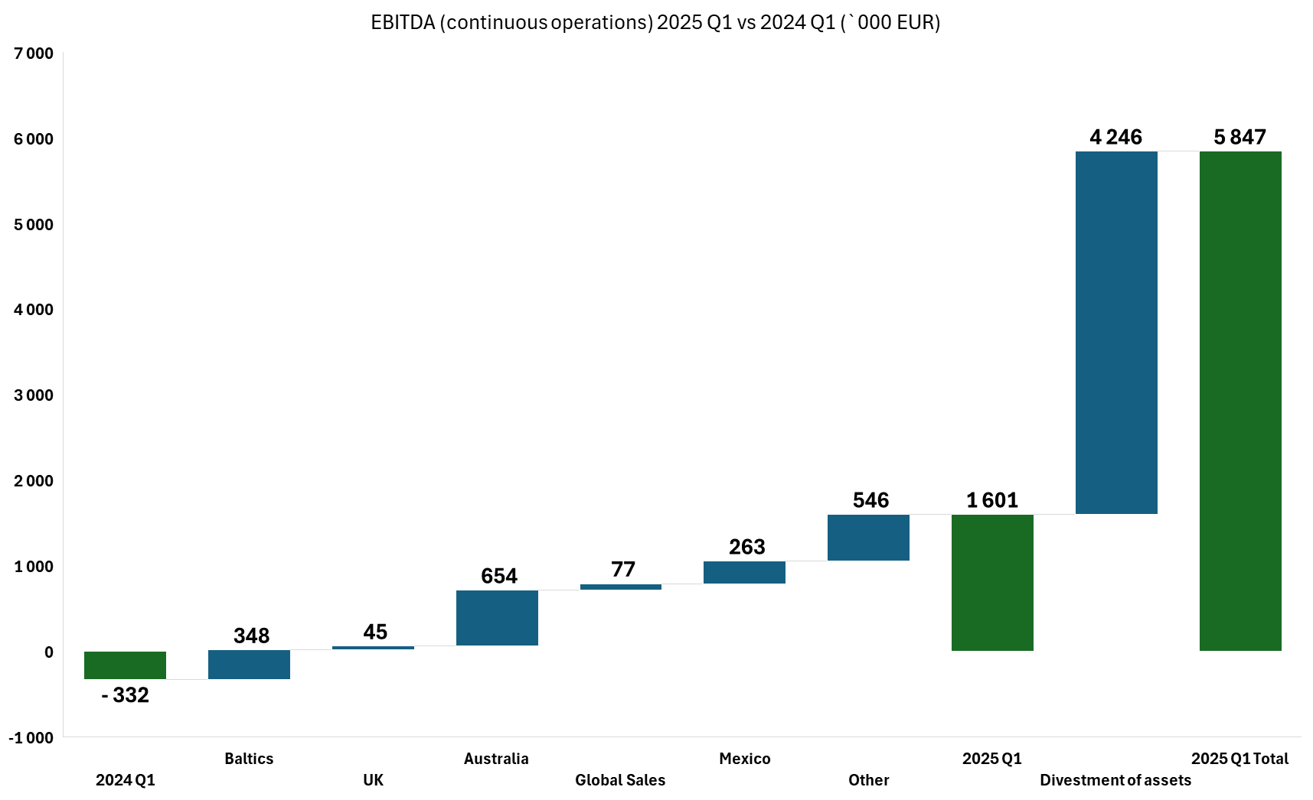

The EBITDA in the three months of year 2025 amounts to EUR 5.8 million and rapidly increased on 6 million as the result of our strategic focus on stabilizing profitability, improving operational efficiency, and strengthening our financial position. We are actively pursuing refinancing opportunities and strategic partnerships to support growth and create long-term value.

The operating profit in the three months of year 2025 amounts to EUR 4.1 million, which is significantly higher (by EUR 6.5 million) than in the respective period of 2024. Meanwhile, the Group has continued and will continue to work on efficiency improvements - revenue management, sales promotion, and demand planning, improvements in customer relationship management, as well as non-stop process improvements in production and logistics using Lean methodology. As a Group, we carefully monitor market development and will take the necessary steps to increase profitability.

MANAGEMENT REPORT (continued)
Financial Ratios as of 31.03.2025 are disclosed below:
Ratio |  | 31.03.2025 | 31.12.2024*
Gross Margin Ratio |  | 33,5% | 30,7%
ROA |  | -0,2% | -1,1%
ROE |  | -0,5% | -2,5%
Debt/Equity |  | 59% | 61%
Equity Ratio |  | 44% | 43%
*the 2024 annual accounts are still subject to audit, and as a result, the ratios may be subject to change.

Funding profile
The Group maintains a well-leveraged capital structure to support the growth of the business. The borrowings comprise loans
from the Luminor Bank AS Latvian branch, Credit Suisse AG, and Rietumu Banka AS supporting the long-term investments, as well as overdrafts and credit lines provided by the Luminor Bank AS Latvian branch, BluOr Bank AS, Westpac, and Ultimate Finance to support the net-working capital needs and long-term unsecured loan facilities from related parties.
Since the beginning of the year, the Company has decreased its debt from EUR 103.5m to EUR 96.8m, which has also decreased interest expenses.

As at the 31 March 2025 the composition of the debt by partners is as following:
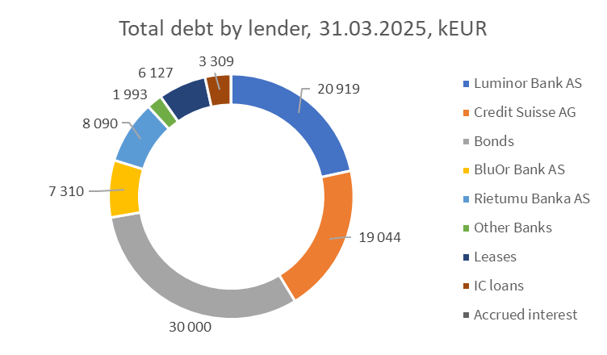
Financial liabilities | Maturity less than 1 year  EUR 000 | Maturity more than 1 year  EUR 000
Luminor Bank AS | 20 919
Credit Suisse AG | 19 044
Bonds |  | 30 000
BluOr Bank AS | 7 310
Rietumu Banka AS |  | 8 090
Other Banks | 1 974 | 19
Leases | 2 797 | 3 330
IC loans | 36 | 3 273
Accrued interest | 23

MANAGEMENT REPORT (continued)
The trading activity on the Frankfurt Stock Exchange for the period 1Q 2025 has been as follows:
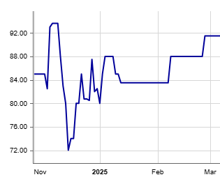
(Source: Frankfurt Stock Exchange)

As part of the terms and conditions of the Offering Memorandum, the proceeds from the bond issue can be utilised to fund the construction of the project and to serve the respective debt. In 2025, the Parent Company has continued to work on overall loan portfolio optimisation.

Non-financial performance and activities for the reporting period

The total net revenue from continuous operations of EUR 42.8 million has been generated mainly by sales of Vodka. Another important value drivers are Whiskey, Brandy, Cognac and Wine, Sparkling, Cider categories:

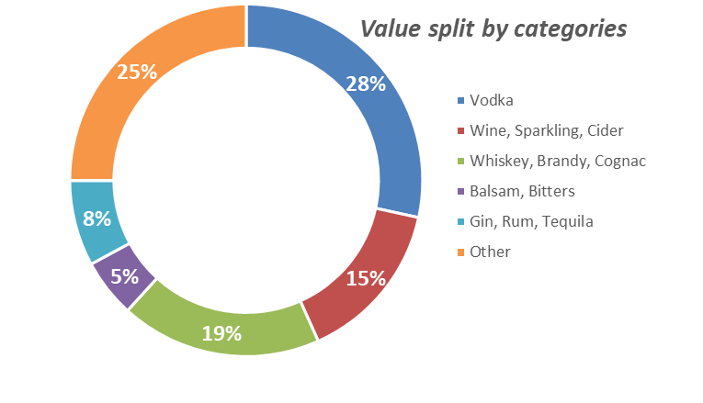

MANAGEMENT REPORT (continued)
ABG brands contributed 29% of the total volume of 1.3 million 9Lcs. Core brands amount to 48% of total ABG brands sold.
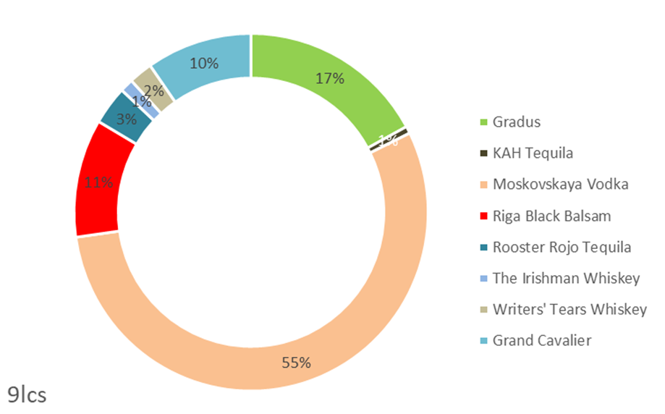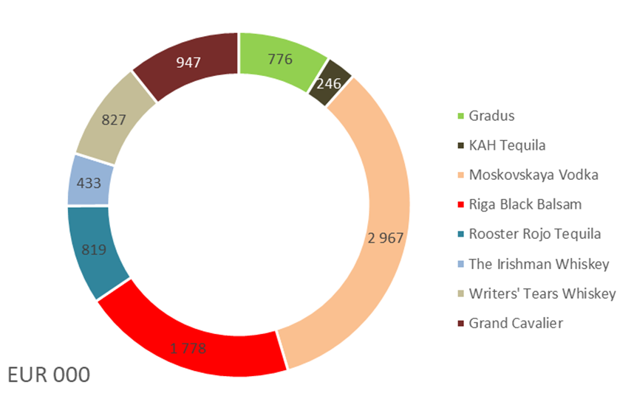
Financial risk management
In the ordinary course of business, the Group is exposed to a variety of financial risks, including credit risk, liquidity risk, and interest rate risk. The Group’s management handles financial risks on an ongoing basis to minimize their potential adverse effects on the financial performance of the Group.
Financial assets that potentially expose the Group to a certain degree of credit risk concentration are primarily trade receivables, receivables from related companies, and loans. ABG performs regular assessment of customers credit worthiness (adhering to IFRS 9 regulations), thus improving payment discipline. The Group also complies with sanctions regimes imposed by the EU, United Nations, and US, as well as internal procedures.
The Group has faced challenges in maintaining sufficient liquidity to meet business needs and fulfil obligations to banks, suppliers, and government institutions. Declining revenues make it difficult to ensure timely payments to creditors. To address liquidity risks, the Group’s management has several priorities:
- To improve liquidity forecast by closely monitoring cash inflows and outflows
- Boost the use of factoring and refinance expensive loans on better terms
- To eliminate business lines that are unprofitable or have low profit margins
- Tight control over operating expenses, including renegotiating contracts with suppliers
- To sell non-core assets and attract new investments.
Interest rate risk is present as most of the borrowings have variable interest rates. The Group’s management have intention to phase down total level of borrowings to reduce interest payments. Another focus is to improve working capital to avoid the necessity to take new loans.

On behalf of the Board:
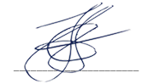
Arturs Evarts
Chairman of the Board
Luxembourg, 30 May 2025
Statement of the Board of Managers’ Responsibilities for the Preparation and Approval of the Consolidated Financial Statements

(for Unaudited Condensed Consolidated Financial Statement for first three months of 2025)

The Board of Managers is responsible for the preparation, publishing and fair presentation of the consolidated financial statements in accordance with Luxembourg legal and regulatory requirements relating to the preparation and presentation of the consolidated financial statements, and for such internal control as the Board of Managers determines is necessary to enable the preparation of consolidated financial statements that are free from material misstatement, whether due to fraud or error. In preparing the consolidated financial statements, the Board of Managers is responsible for assessing the Group’s ability to continue as a going concern, disclosing, as applicable, matters related to going concern and using the going concern basis of accounting unless the Board of Managers either intends to liquidate the Group or to cease operations, or has no realistic alternative but to do so.
We confirm that to the best of our knowledge and belief:
• The consolidated financial statements of Amber Beverage Group S.à r.l. (the ‘Company’) presented in this unaudited interim Report and established in conformity with International Financial Reporting Standards as adopted by the European Union give a true and fair view of the consolidated statements of comprehensive income, changes in equity and cash flows for the year that ended, and notes to the consolidated financial statements, including a summary of significant accounting policies; and
• The Directors' Report includes a fair review of the development and performance of the business and position of the Company and the undertakings included within the consolidation taken as a whole, together with a description of the principal risks and uncertainties it faces.

Approved by the Board of Managers and signed on its behalf on 30 May 2025 by:

On behalf of the Board:
Arturs Evarts
Chairman of the Board
Luxembourg, 30 May 2025

CONSOLIDATED STATEMENT OF COMPREHENSIVE INCOME

 |  | 01.01.2025-31.03.2025 | 01.01.2024-31.03.2024
 | Notes | EUR 000 | EUR 000
Continuing operations
Revenue |  | 69 848 | 87 464
Excise and duties |  | (27 074) | (31 597)
Net revenue |  | 42 774 | 55 867
Cost of goods sold | 4 | (28 425) | (41 966)
Gross profit |  | 14 349 | 13 901
Selling expenses | 5 | (9 908) | (10 796)
General and administration expenses | 6 | (4 869) | (6 286)
Net impairment gain/ (losses) of financial assets |  | (8) | (64)
Fair value adjustment on biological assets |  | - | -
Other operational income |  | 5 035 | 1 382
Other operational expense |  | (498) | (636)
Merger and acquisition related costs |  | - | 142
Operating profit/ (loss) | 3 | 4 101 | (2 357)
Net finance income/ (expense) | 7 | (2 483) | 359
Profit/ (loss) before tax from continuing operations |  | 1 618 | (1 998)
Corporate income tax | 8 | (566) | (760)
Profit/ (loss) for the period from continuing operations |  | 1 052 | (2 758)
Discontinued operations
Profit/ (loss) after tax from discontinued operations |  | - | (534)
Profit / (loss) for the period |  | 1 052 | (3 292)
Attributable to:
Equity holders of the parent |  | 966 | (3 282)
Non-controlling interest |  | 86 | (27)
 |  | 1 052 | (3 309)
Other comprehensive income |  | (916) | 1 202
Total comprehensive income/ (loss) for period |  | 136 | (2 107)

Attributable to:
Equity holders of the parent |  | 51 | (2 043)
Non-controlling interest |  | 85 | (64)
 |  | 136 | (2 107)
On behalf of the Board:
Arturs Evarts
Chairman of the Board
Luxembourg, 30 May 2025
CONSOLIDATED STATEMENT OF FINANCIAL POSITION

ASSETS
 |  | Notes | 31.03.2025 | 31.12.2024*
Non-current assets |  |  | EUR 000 | EUR 000
 | Intangible assets |  | 85 211 | 85 997
 | Property, plant and equipment |  | 66 969 | 72 358
 | Rights-to-use assets |  | 8 209 | 8 526
 | Biological assets |  | 542 | 584
 | Non-current portion of loans to related parties |  | 29 560 | 29 560
 | Other non-current financial assets |  | 2 319 | 2 334
 | Non-current financial investments |  | 2 436 | 2 315
 | Deferred tax asset |  | 109 | 221
 | TOTAL NON-CURRENT ASSETS |  | 195 355 | 201 895
Current assets
 | Inventories | 9 | 65 791 | 60 147
 | Trade and other receivables | 10 | 98 649 | 118 703
 | Loans to related parties |  | 8 976 | 8 385
 | Corporate income tax |  | 1 312 | 1 484
 | Short term bank deposits |  | - | -
 | Cash and cash equivalents | 11 | 5 132 | 8 737
 | TOTAL CURRENT ASSETS |  | 179 860 | 197 456
TOTAL ASSETS |  |  | 375 215 | 399 351

* 2024 annual accounts are still subject to audit, and as a result, the opening balance may be subject to change.

CONSOLIDATED STATEMENT OF FINANCIAL POSITION (continued)

 |  | Notes | 31.03.2025 | 31.12.2024*
Capital and Reserves |  |  | EUR 000 | EUR 000
 | Share capital |  | 13 | 13
 | Share premium |  | 132 553 | 132 553
 | FX revaluation reserve |  | (4 636) | 697
 | Other reserves |  | 1 | 1
 | Asset revaluation reserve |  | 523 | 523
 | Pooling reserve |  | (306) | (306)
 | Retained earnings |  | 23 708 | 22 742
 | Total equity attributable to the owners of the parent |  | 151 856 | 156 223
Non-controling interest |  |  | 12 587 | 14 195
 | TOTAL EQUITY |  | 164 443 | 170 418
Liabilities
Non-current liabilities
 | Borrowings | 14 | 6 501 | 6 929
 | Trade and other payables | 12 | 8 | 8
 | Deferred tax liability |  | 5 549 | 5 000
 | TOTAL NON-CURRENT LIABILITIES |  | 12 058 | 11 937
Current liabilities
 | Borrowings and bank overdrafts | 14 | 90 314 | 96 573
 | Trade and other payables | 12 | 66 249 | 77 382
 | Taxes payable | 13 | 41 267 | 43 039
 | Corporate income tax liabilities | 13 | 884 | 2
 | TOTAL CURRENT LIABILITIES |  | 198 714 | 216 996
 | TOTAL LIABILITIES |  | 210 772 | 228 933
TOTAL EQUITY AND LIABILITIES |  |  | 375 215 | 399 351

* 2024 annual accounts are still subject to audit, and as a result, the opening balance may be subject to change.

On behalf of the Board:
Arturs Evarts
Chairman of the Board
Luxembourg, 30 May 2025

* the 2024 annual accounts are still subject to audit, and as a result, the opening balance may be subject to change.

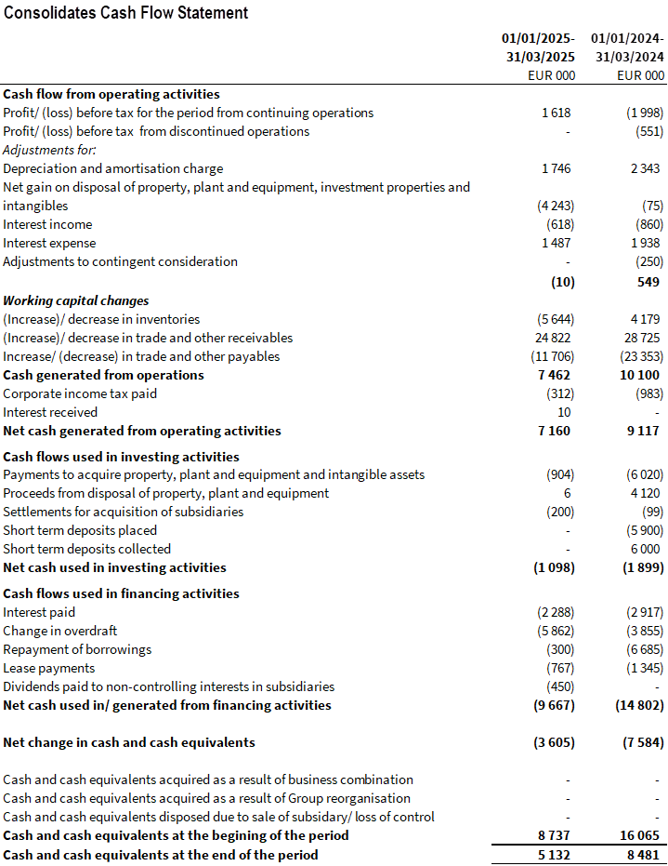

NOTES

- GENERAL INFORMATION
These unaudited condensed consolidated financial statements were approved and authorised for issue by the Board of Managers of Amber Beverage Group Holding S.à r.l. (the Parent Company) on 30 May 2025.
The Parent Company was incorporated on 26 September 2017 under the laws of the Grand Duchy of Luxembourg with the registered number B218246 as Amber Beverage Group Holding S.à r.l. The Parent Company’s registered office is at 44 Rue de la Vallée, L-2661, Luxembourg.
As of 31 March 2025, Amber Beverage Group (further on – the Group or ABG) consists of the Parent Company and its subsidiaries (see also Note 19).
- ACCOUNTING POLICIES
Basis of Preparation
The unaudited condensed consolidated financial statements for Q1 2025 of the Group have been prepared in accordance with IAS 34 Interim Financial Reporting.
The financial information for 2024 presented in this report has been compiled based on the published unaudited annual accounts for the reporting period. The annual accounts are still subject to audit, and as a result, the opening balance may be subject to change.
Any adjustments arising from the audit process will be reflected in the final version of the accounts.

Basis for consolidation
The consolidated financial statements incorporate the financial statements of the Parent Company and entities controlled by the Parent Company (its subsidiaries). Control is achieved when the Group is exposed, or has rights, to variable returns from its involvement with the investee and can affect those returns through its power over the investee. Specifically, the Group controls an investee if and only if the Group has:
- Power over the investee (i.e., existing rights that give it the current ability to direct the relevant activities of the investee).
- Exposure, or rights, to variable returns from its involvement with the investee.
- The ability to use its power over the investee to affect its returns.
Generally, there is a presumption that the majority of voting rights result in control. To support this presumption, and when the Group has less than a majority of the voting or similar rights of an investee, the Group considers all relevant facts and circumstances in assessing whether it has power over an investee, including:
- The contractual arrangement with the other vote holders of the investee.
- Rights arising from other contractual arrangements.
- The Group’s voting rights and potential voting rights.
The Group re-assesses whether it controls an investee if facts and circumstances indicate that there are changes to one or more of the three elements of control. Consolidation of a subsidiary begins when the Group obtains control over the subsidiary and ceases when the Group loses control of the subsidiary. Assets, liabilities, income, and expenses of a subsidiary acquired or disposed of during the year are included in the consolidated financial statements from the date the Group gains control until the date the Group ceases to control the subsidiary.

Functional currency and revaluation
The functional and presentation currency of the main Group entities is the euro (EUR), as the European Union is the primary economic environment in which the Group’s subsidiaries operate. These consolidated financial statements are presented in thousand euros (unless stated otherwise).
In preparing the financial statements of each individual group entity, transactions in currencies other than the entity’s functional currency (foreign currencies) are recognised at the rates of exchange prevailing at the dates of the transactions. At the end of each reporting period, monetary items denominated in foreign currencies are retranslated at the rates prevailing at that date.
During the consolidation process for entities with functional currency other than the functional currency of the Parent Company, the positions of the statement of financial position are revalued at the year–end exchange rate, and the positions of the statement of comprehensive income, cash–flow statement, and statement of changes in equity are revalued at the average exchange rate for the reporting period (or the average exchange rate for the period the Group has obtained control).
The following foreign currency exchange rates have been applied:

 | Average for period 01/01/2025-31/03/2025 | Average for period 01/01/2024-31/03/2024 | Closing rate as of 31.03.2025 | Closing rate as of 31.12.2024
USD/EUR | 1,0523 | 1,0858 | 1,0815 | 1,0389
AUD/EUR | 1,6772 | 1,6511 | 1,7380 | 1,6772
GBP/EUR | 0,8357 | 0,8563 | 0,8354 | 0,8292
RUB/EUR | 97,9779 | 98,4985 | 92,4184 | 92,4184
MXN/EUR | 21,4988 | 18,4492 | 22,0627 | 21,5504
CHF/EUR | 0,9499 | 0,9491 | 0,9531 | 0,9412
CAD/EUR | 1,5105 | 1,4639 | 1,5553 | 1,4948

Exchange differences on monetary items are recognised in the statement of comprehensive income in the period in which they arise.
Changes in accounting policy and disclosures
The accounting policies adopted in the preparation of the interim condensed consolidated financial statements are consistent with those followed in the preparation of the Group’s annual consolidated financial statements for the period ended 31 March 2025. The Group has not early adopted any standard, interpretation, or amendment that has been issued but is not yet effective. The Group intends to adopt the above standards and interpretations and evaluate their effects on the effective date.

- OPERATING PROFIT

- COST OF GOODS SOLD

- Selling EXPENSES

- General and ADMINISTRATIVE EXPENSES

- NET FINANCE INCOME/ (EXPENSES)

- CORPORATE INCOME TAX

- INVENTORIES

- TRADE AND OTHER RECEIVABLES
 |  | 31.03.2025 |  |  |  | 31.12.2024*
 |  | EUR 000 |  |  |  | EUR 000
Gross trade receivables |  | 44 099 |  |  |  | 67 891
Expected credit loss allowance |  | (1 532) |  |  |  | (1 558)
Net trade receivables |  | 42 567 |  |  |  | 66 332
Receivables from related parties |  | 41 780 |  |  |  | 42 084
Accrued income |  | 2 549 |  |  |  | 3 086
Prepayments |  | 1 861 |  |  |  | 2 045
Other debtors |  | 9 892 |  |  |  | 5 155
Total |  | 98 649 |  |  |  | 118 703

- CASH AND CASH EQUIVALENTS
 |  | 31.03.2025 |  | 31.12.2024*
 |  | EUR 000 |  | EUR 000
Cash at bank |  | 3 833 |  | 6 220
Short term deposits |  | 1 056 |  | 2 381
Petty cash |  | 8 |  | 7
Cash in shops |  | 59 |  | 99
Cash in transit |  | 176 |  | 30
Total |  | 5 132 |  | 8 737

- TRADE AND OTHER PAYABLES
 |  | 31.03.2025 |  | 31.12.2024*
 |  | EUR 000 |  | EUR 000
Trade payables |  | 36 062 |  | 48 196
Accrued expense |  | 10 064 |  | 11 131
Payables to related parties |  | 2 978 |  | 2 778
Vacation reserve |  | 1 837 |  | 1 687
Contingent consideration |  | 550 |  | 750
Salaries payable |  | 1 198 |  | 982
Dividends payable |  | 8 923 |  | 9 374
Advances received |  | 1 306 |  | 714
Deferred income |  | 295 |  | 336
Other payables |  | 3 044 |  | 1 442
Total |  | 66 257 |  | 77 390

- TAXES PAYABLE
 |  | 31.03.2025 |  | 31.12.2024*
 |  | EUR 000 |  | EUR 000
Excise tax |  | 28 999 |  | 29 787
Value added tax |  | 9 277 |  | 10 761
Corporate income tax |  | 884 |  | 2
Other |  | 2 991 |  | 2 491
Total |  | 42 151 |  | 43 041

- NET BORROWINGS

- GROUP STRUCTURE
Name | Principal activities | Country of incorporation | % Equity interest 31/03/2025 | % Equity interest 31/12/2024
Amber Beverage Group Holding S.à r.l. (Parent Company) | Holding and management activities | Luxembourg | - | -
Amber Distribution Latvia SIA | Distribution | Latvia | 100% | 100%
Interbaltija Amber SIA | Distribution | Latvia | 100% | 100%
Amber Distribution Estonia OU | Distribution | Estonia | 100% | 100%
Amber Distribution Lithuania UAB | Distribution | Lithuania | 100% | 100%
Amber Beverage UK Ltd | Distribution | The UK | 100% | 100%
Amber Beverage Australia Pty Ltd | Distribution | Australia | 100% | 100%
Amber Beverage Austria GmbH | Distribution | Austria | 100% | 100%
Amber Beverage Germany GmbH | Distribution | Germany | 100% | 100%
Indie Brands Ltd | Distribution | The UK | 100% | 100%
Indie Spirits Ltd | Distribution | The UK | 100% | 100%
WW Equity House Holding Ltd | Holding activities | Ireland | 100% | 100%
WW Equity House Trading Ltd | Distribution and brand management | Ireland | 100% | 100%
Amberbev International Ltd | Distribution | Cyprus | 100% | 100%
Amber Latvijas balzams AS | Production of alcoholic beverages | Latvia | 89,99% | 89.99%
Amber Production Tequila S.A. de C.V. | Production of alcoholic beverages | Mexico | 100% | 100%
Amber Agave S.A. de C.V. | Agricultural activities | Mexico | 100% | 100%
Amber Production Remedia OU | Production of alcohol beverages | Estonia | 100% | 100%
Amber IP Brands S.à r.l. | Intellectual property rights management | Switzerland | 100% | 100%
Amber Beverage Group SIA | Management services | Latvia | 100% | 100%
Think Spirits NL B.V. | Management services | The Netherlands | 100% | 100%
ABG Real Estate SIA | Real estate management | Latvia | 100% | 100%

- SUBSEQUENT EVENTS

On the April 14, Supervisory Board Chairman Sir Geoffrey John Mulgan has been removed from his position upon his own wish.

Financial indebtedness towards UBS (former Credit Suisse) and Luminor has been reduced in amount of EUR 3,7 M in April.

On behalf of the Board:
Arturs Evarts
Chairman of the Board
Luxembourg, 30 May 2025

